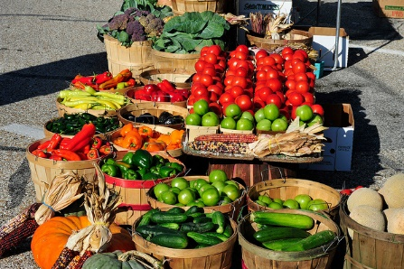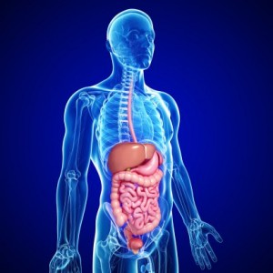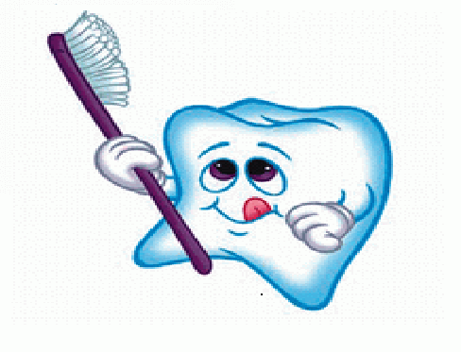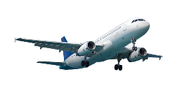 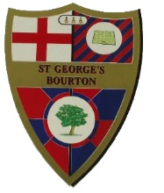

**MUSIC**

* Listen and appraise different music and songs
* Considering impact of lyrics
* Reggae music

**R.E.**

**Incarnation** – Christmas

**P.S.H.E.**

**Valuing differences**

Anti-bullying, Celebrating diversity

**Geography**

**Where does our food come from?**

* Climate zones, biomes and land use
* Map work
* Food miles
* Visit to Wyke Farm – Farm to fork. Monday 21st November – more details to follow nearer the time
* Human changes of land use and the impact of this

**Forest Schools** (Wednesdays)

* Basket weaving

**P.E.**

**Monday –** ?? – With Mr Betts

**Friday –** Fitness - Circuits

**MATHS**

* Addition and Subtraction: adding 2-digit numbers with out carrying
* Multiplication and division: x4 (Yr3) and x3, x6 & x 9 (y4);
* Geometry – properties of 2D and 3D shapes
* Measures – Time to the nearest 5 minute and 1 minute

**ENGLISH**

* Non-fiction writing – explanations – how is chocolate made? How is our food produced?
* Fiction – Stories with a character flaw
* Grammar focus – conjunctions, inverted commas, apostrophes
* Class Reader – The Demon Dentist – David Walliams
* Spellings (tested on a Friday) suffixes -ture, -ation, -ion, and c spelt ch and sh

**SCIENCE**

**Animals and humans – teeth and digestion**

* How nutrients, water and oxygen are transported within animals and humans
* Parts and functions of the human digestive system
* Different types and function of teeth.
* Scientific enquiry

**FRENCH**

* Family
* Numbers 1-20
* Retell simple stories and rhymes.

**Gums and Tums**

**Badgers – Autumn 2022 Term 2**